A55-AM,S-Colombia-Tairona-Gold Pectoral-Hairless Dog-Double Head-1000-1500 CE

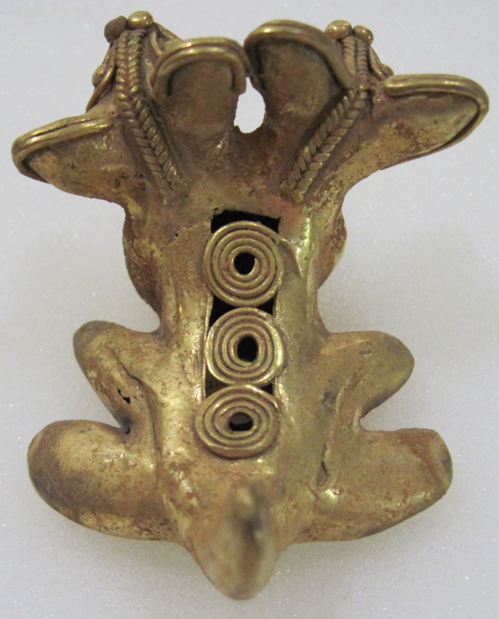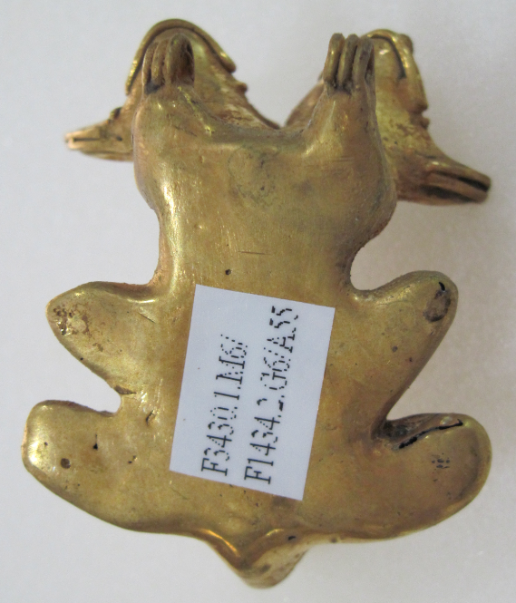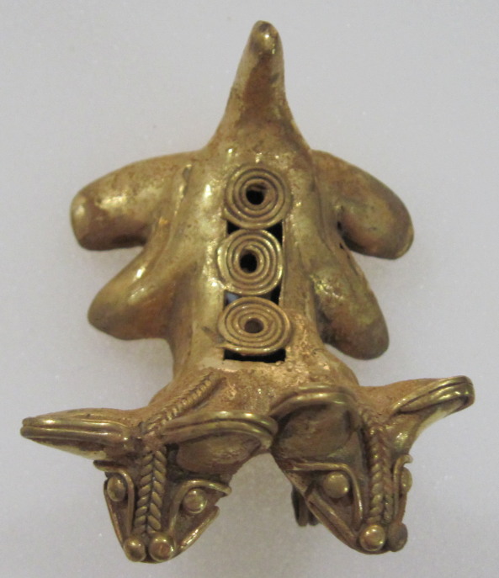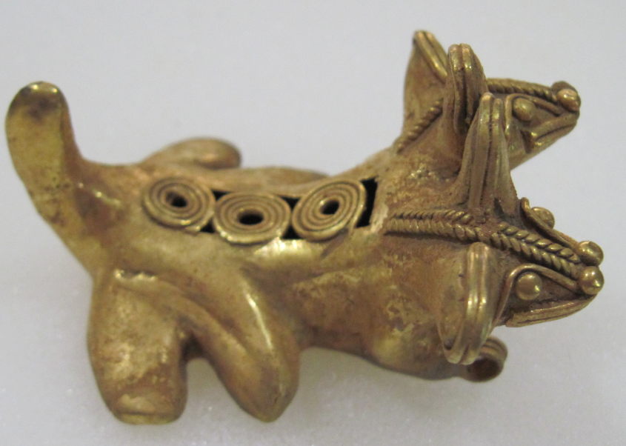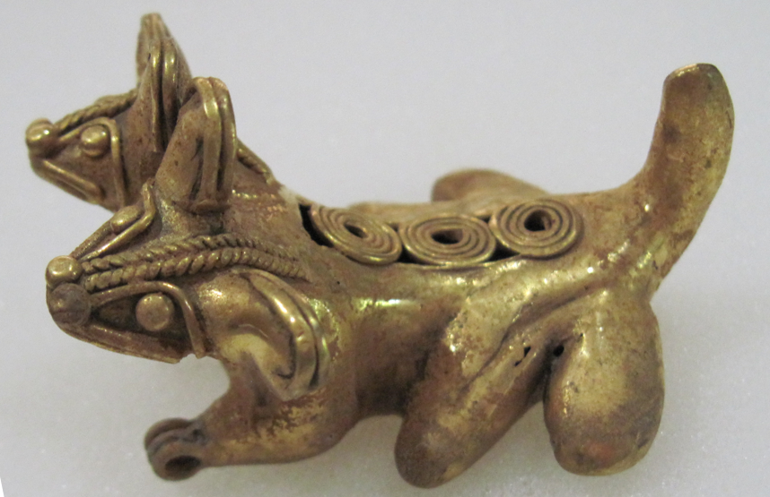

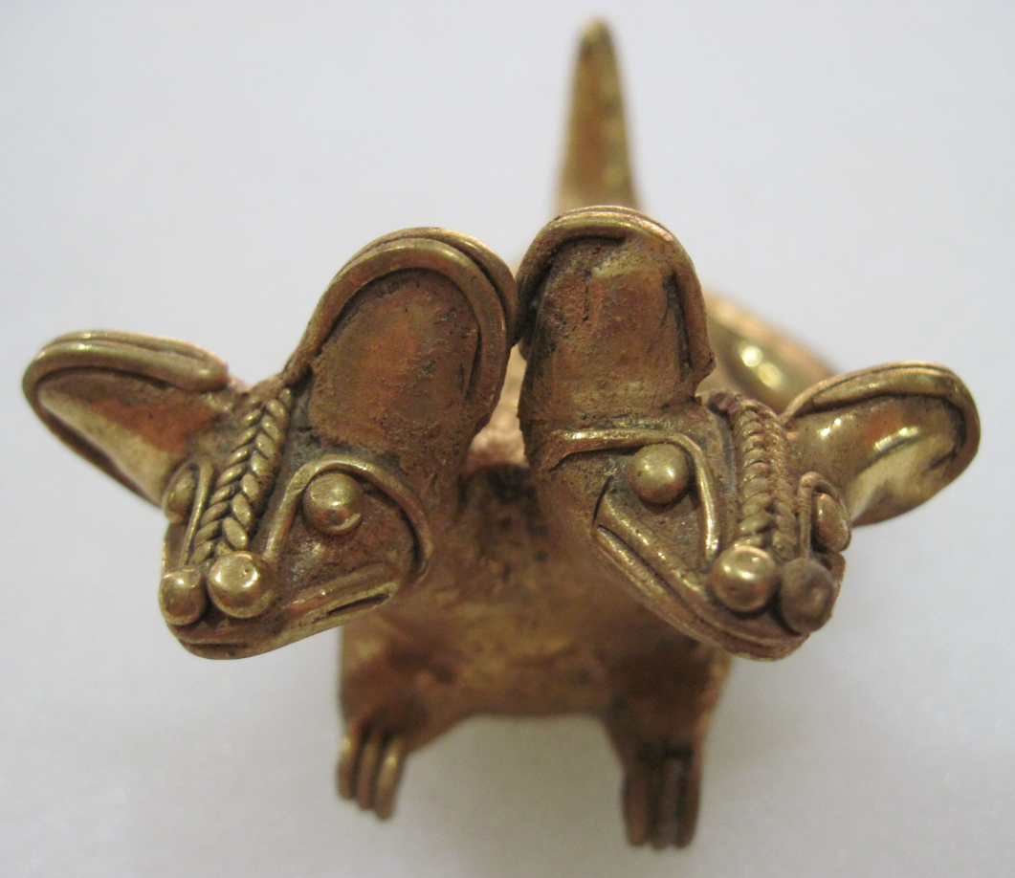

Figs. 1-6. Colombia-Tairona-Gold Pectoral-Hairless Dog-Double Head-1000-1500 CE

**Case No.: 7**

**Formal Label:** Colombia-Tairona-Gold Pectoral-Hairless Dog-Double Head-1000-1500 CE

**Display Description:** Colombia-Tairona-Gold Pectoral-Hairless Dog-Double Head-1000-1500 CE. This gold figurine is of a *Hairless Dog with a double head* of the prehistoric (1000-1500 AD/CE) Tairona culture of the Sierra Nevada de Santa Marta**, Colombia**. By 1000 AD/CE Tairona goldsmiths, using the lost wax method, had attained one of the highest levels of technical and artistic achievement in gold-working the Americas.

This figurine portrays a breed of hairless dog that dates from at least 700 CE when the Moche (200-700 CE) made ceramic figurines of this dog, which were buried with the deceased as company in the afterlife, since Peruvians bred this house dog as companions as well as bed warmers. They were often kept in the same room as orchids where the humidity helped to preserve their silky smooth skin, which is why the Spaniards called them *orquídea perro* or orchid dogs. The Inca called the hairless dog allqu, which meant a common domesticated dog, so it must have been a common Inca pet. The psychological, if not the spiritual, effect of maintaining a pet like this dog would have been soothing to the psyche as it was bred to be calm and loving. Indeed, the Tairona and the Kogi maintained that,

“The ultimate achievement of the soul consists on becoming *seiváke* during one’s lifetime and in wandering over *seivákein géina* during the afterlife. To be truly reborn (*ishkuéldyi*), the soul must have arrived at a state of innocence like that of an uninitiated boy, a state of youthful flawlessness (*zueldúxa* ). The concept of purity refers above all to sexual innocence and emphasis is placed upon the boyish image as something ‘whole, complete, perfect like a child’. Another condition of the state of *seiváke* is called *nakuíza*, meaning ‘he who forgot’. A *seiváke* person must have forgotten everything he has learned during his lifetime, a state that must be achieved by an intentional mental effort at unlearning and thus returning to a childlike state. A third condition of *seiváke* is called *sui séishi*, ‘to feel cold’. The person must have mastered all emotions such as passion, lust, sorrow, and anger. One priest said: “The body must become all thought. There must be no thoughts of women, no thoughts of a body that has orifices.” So *seiváke* means cold, virginal, innocent; it stands for thoughts devoid of all sensuality, unaware of, or rather, beyond sex. In summary, the person must lose his or her sexual and personal individuality.”

This dog would have been an assist in helping a family of the Kogi, who are a deeply religious people, to maintain the difficult task of psychological balance in daily routines essential to achieving *seiváke*. For instance, the use of hallucinogens is frowned upon by the Mámas since “truly illuminating experiences must be endogenously produced by disciplined sensory deprivation and by concentration.” Hairless dogs could be used as animal helpers in this process. On these occasions a *Máma* will not speak of jaguar monsters or cannibal spirits; these are creatures of one’s own imagination and each person has to vanquish them in his own solitude. Instead he will speak of the Great Mother who said to Sintána when, after his long wanderings, he returned and broke out in tears: “Never fear, my son; I shall always save you.” This is a ‘*mulkuákve*’, a prayer or religious formula that a Máma may use for meditation or counselling someone asking his advice;

iskími alúna hangu ité  
  iskími hába guaselgukú hangu ité  
  iskími mulyigába nici gataugénka  
  iskími hiúngulda guxa nici naugénka

  Only one thought,  
  Only one Mother,  
  Only one single word reaches upwards,  
  Only one single trail leads heavenward.

The trail may have been prepared by the hairless dog as an animal helper to his master. Gerardo Reichel-Dolmatoff (1950-1951) concludes; “The Kogi cherish their culture, they believe in it, and from this certainty they derive a deep satisfaction.” The hairless dog may have been a psychological assist in this process.

**Accession Number:** A55

**LC Classification:**  F1434.2

**Date or Time Horizon:** 1000-1500 CE

**Geographical Area:** Sierra Nevada de Santa Marta**, Colombia. Indigenous names are:** Kankuamo (*Umunukunu);* Kogi (*Gonawindua).*

**Map, GPS Coordinates:**



Fig. 7. Map of Spanish Provinces in 1600. After <https://html2-f.scribdassets.com/5nmwqq7itc4aqx2e/images/6-a5a093175f.jpg>. Yellow place-holders mark the social “centroids” of k-means clustering algorithms of the four Tairona cultures (in bold) as of 2017 (see Rajput et al. 2012).

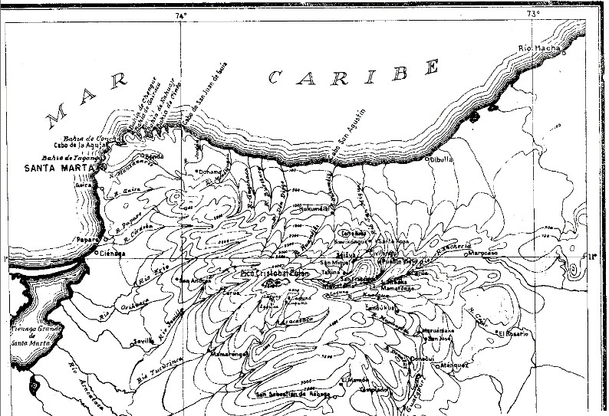

Fig. 8. Topographic map of the Sierra Nevada of NE Colombia. From Reichel-Dolmatoff 1950.

**Cultural Affiliation:** Tairona, Chibcha Language

**Medium:** Lost-wax cast of tumbaga, an alloy of gold and copper. Its surface was subsequently enriched by the depletion method, also known as *mise-en-couleur*.

**Dimensions:** L 57.61 mm, 2.27 in

**Weight: 109 gm; 3.78 oz; H 33.13 mm, 1.3 in**

**Condition: original**

**Provenance:** Tairona villages

**Discussion:**

Only in 1965 did Colombian archaeologists uncover a previously unrecorded mountain trail of 1,200 steps in the rain forest on the slopes of Sierra Nevada de Santa Marta, which led to an ancient abandoned city (“Ciudad Perdida”; 11°02'22.9"N 73°55'33.8"W) where gold figurines like this hairless dog and ceramic urns were later unearthed. Tairona descendants—the Arhuaco and the Kogi—re-called the site which they called “Teyuna” with its series of 169 terraces and several small circular plazas. Within Teyuna the open, permeable system of unstructured staircases allowed all to participate in a visual and social equality in which the display of gold appurtenances and valued feather headdresses denoted symbols of potential social productiveness accessible to all members of Tairona society. This “open society” can be appreciated in the plot plan and side views of Teyuna’s main cluster of houses (see Fig. 8). Teyuna’s configuration emerged relatively late in the building sequence (ca 11-12th century AD/CE), following an incremental pattern as new areas were added to pre-existing ones by paved paths and staircases that allowed access to any compound from multiple directions thereby ensuring a continuous flow of people to and from any part of the village. Rectangular ceremonial structures excavated by John Alden Mason in 1921/1922 (Fig. 8, no. 52; Mason 1931, 1936) unearthed numerous fragments of double spouted ceramic urns for brewing corn beer, *chichi*.



Fig. 8. Double-spouted *chichi* vessel restored, after Mason 1931, plate CLXXI. Illustrating Great Mother Creator, Gaulcováng and Her children -- Lords of the Cosmos, Seokúkui and Seizankwa.

Artifacts inside these buildings and nearby residences suggest that these locations served as distributed repositories of valued ceremonial goods, such as stone batons and monolithic axes (as symbols of authority and power), winged pendants (used as tinklers suspended from the arms in dances), and beads (carnelian, jadeite, quartz).





Figs. 9-10. North End of Ciudad Perdida's Central sector (plot plan and side view) showing the rectangular ceremonial center (no. 52) and the overlaps of sequential construction with the altitudinal distances between terraces and subsidiary staircases connected to the main staircase. From drawings by Peter Kellett and Angela Uribe Kellett, 1984 (Today, however, many Kogi and Arhuaco villages have walls the exclude non-Tairona peoples from entering (see below).



Fig. 11. Sign posted on the entryway to an Arhuaco village stating “The entry of non-indigenous people is prohibited …”. From <http://assets.survivalinternational.org/pictures/2021/img-2313_screen.jpg>. This kind of isolation of the Kogi people would have fostered the climate to develop the Hairless Dog characteristics.

Kogi philosophy is based on *aluna*, cosmic harmony. The Great Mother Creator, Gaulcováng (from gau – “to create”), has many manifestations, such as ***Hába Guxsénse***, “Mother of the Eternal Fire,” and Málkwa-yang, “Mother of the Knowledge of Weaving.” Her children -- Lords of the Cosmos, Seokúkui and Seizankwa -- carry Gaulcováng’s Cosmic Egg balanced between two poles between them on their shoulders. When the Cosmic Egg shifts in balance between them, metaphorical earthquakes can result. The metaphysical may have physical consequences, so that right relations with one’s neighbors and the Earth is essential to maintaining cosmic balance.

The Kogi Cosmic Egg is composed of nine worlds that correspond to the nine months of human gestation (Tairona 2015).



Fig. 12. Structure of the Kogi Cosmic Egg. Based on Reichel-Dolmatoff 1978, from Tairona 2015.

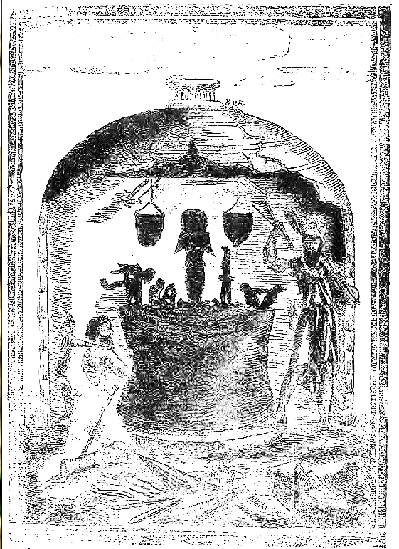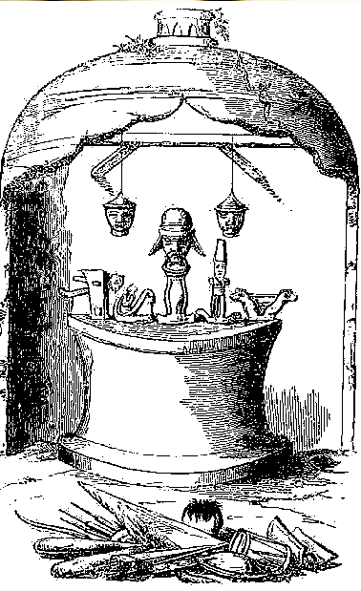

Fig. 13. “The idolary of the Indians of the Arhuacos Nation who live in the Sierra de Santa Marta, destroyed by a religious of the order of Saint Augustin of the Province of Lima and the Law of [16]91 . [This is] one of their temples in which are found the abominable cultic idols to the Devil.” From Romero 1693.

Fig. 14. “Representation of one of the shrines of the Arhuaco Indians in the Sierra Nevada of Santa Marta, destroyed by Father Francisco Romero, of Augustin order.” From Acosta 1848.

Figs. 13 and 14 are two views of the shrine that was desecrated by Father Francisco Romero, of the Augustin Order in the name of the Order of Saint Augustin of the Province of Lima and the Law of [16]91. Its representation is taken from a published account of the destruction in 1693 by Father Romero and a 1848 account and image of th shrine based on a more accurate visual of the original shrine drawn by Joaquin Acosta. The actual idols were deposited in the Vatican Museum where Gerardo Reichel-Dolmatoff secured photographs of them. We have reconstructed this shrine which includes Gaulcováng and her twin sons paired with a feline figure and what appears to be a double-headed hairless dog.

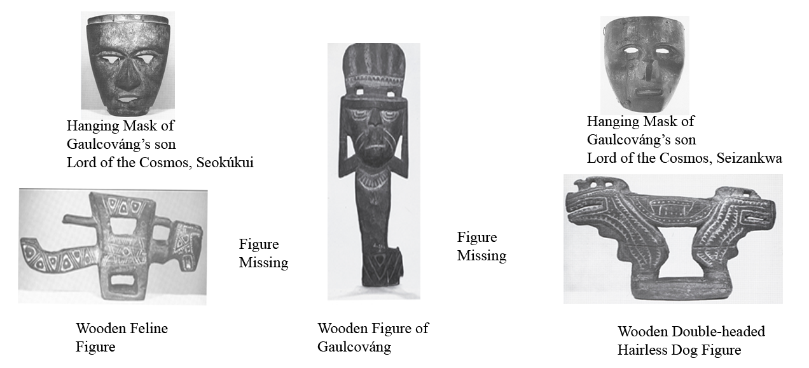

Fig. 15. Reconstruction of the actual shrine desecrated by Father Francisco Romero, of the Augustin Order in the name of the Order of Saint Augustin of the Province of Lima and the Law of [16]91 with the actual figures taken from it and deposited in the Vatican Museum in Rome. After Reichel-Dolmatoff 1990, Plates XLIII, XLVI a, XLVII b,XLV b (reversed), XLIV, XLV a.

It is interesting to note the parallel belief in the hairless dog and the sacrifice of a twin in the Aztec culture in Mesoamerica. Xolotl is represented as a *red* dog, and is distinguished as the deity of air and of the four directions of the wind. His twin is Quetzalcoatl, and both are the twin sons of the virgin Coatlicue, the Aztec goddess who gave birth to the moon, stars, and Huitzilopochtli, the god of the Sun. Since twins in Mesoamerica were considered unnatural, one was usually sacrificed. The sacrificed twin in this case was Xolotl, portrayed as a dog, in the belief that dogs accompanied the souls of the dead to Mictlan, the underworld of Aztec mythology, while his surviving brother, Quetzalcoatl, “The Precious Surviving Twin,” dwells in the light of the Sun (Maffie 2013).



Fig. 16. The Xoloitzcuintle (zoh-loh-eets-kweent-lee), is a hairless breed of dog, found in toy, miniature and standard sizes. It is also known as Mexican hairless dog. From http://www.doggyzoo.com/wp-content/uploads/2014/10/Youngtoyxolo-193x300.jpg.

The actual genetic heritage of the Mexican hairless dog has been identified as coming from a European haplotype that strongly suggests that dogs accompanied the first Amerindians who crossed Beringia into the New World and were subsequently isolated from further genetic intrusions. Thus, the hairless dog was of ancient European stock but remained isolated in the New World and developed its separate characteristics (Leonard and Fisher 2005: 3).

**References**

Acosta, Joaquin. 1848. *Compendio histórico del descubrimiento y colonización de la Nueva Granada en el siglo décimo sexto.*Paris: Imprenta de Beau.

Adelaar, Willem F. H. and Pieter Muysken. 2004. [*The Languages of the Andes*](https://books.google.com/books?id=UiwaUY6KsY8C&pg=PA75). Cambridge: [Cambridge University Press](https://en.wikipedia.org/wiki/Cambridge_University_Press).

Bischof, Henning. 1982-1983. “Indígenas y españoles en la Sierra Nevada de Santa Marta, siglo XVI,” *Revista Colombiana de Antropología*, 24: 75-124.

Bray, W. 2003. “Gold, Stone, and Ideology: Symbols of Power in the Tairona Tradition of Northern Colombia, in: Quilter J., J. W. Hoopes (eds.), *Gold and Power in Ancient Costa Rica, Panama, and Colombia*. (Washington: Dumbarton Oaks Pre-Columbian Conference Proceedings), pp. 301- 344.

Cardoso P.1987. “Uso y significado de las cuentas tairona,” *Boletín del Museo del Oro*, 19: 117-123.

Coleridge, Samuel Taylor. 1950. *The philosophical lectures hitherto unpublished*. Ed. K. Coburn. London: Routledge and Kegan Paul.

D'Anghiera, Peter Martyr. 1555. De Orbo Novo. Trans. Richard Eden as The decades of the newe worlde or west India conteynyng the nauigations and conquestes of the Spanyardes with the particular description of the moste ryche and large landes and Ilands lately founde in the west Ocean perteynyng to the inheritaunce of the kinges of Spayne, Book III, §3. London: William Powell.

[EÑES](https://translate.googleusercontent.com/translate_c?depth=1&hl=en&prev=search&rurl=translate.google.com&sl=es&sp=nmt4&u=https://medium.com/somos-enes%3Fsource%3Dfooter_card&usg=ALkJrhhV4slgnlp8CrzVzf2wyo-CDNCwag). 2017. *La Biblioteca como protectora del mundo*. https://about.me/souldes.

Ereira, Alan. 1993. [The Elder Brothers](http://www.amazon.com/Elder-Brothers-Alan-Ereira/dp/0679743367/ref=tmm_pap_swatch_0?_encoding=UTF8&sr=&qid=). New York: Vintage Books.

Falchetti A.M. 1987. “Desarrollo de la orfebrería Tairona en la provincia metalúrgica del norte

Colombiano,” *Boletín del Museo del Oro*, 19: 3-23.

Fabré, Alain. 2005. [*Diccionario etnolingüístico*](http://www.ling.fi/Entradas%20diccionario/Dic=Chibcha.pdf) y guía bibliográfica de los pueblos indígenas sudamericanos. Internet Electronic File.

Frank, Paul S. 1992. “Reconstrucción de las variaciones en Proto-Aruaco,” *Thesaurus (*Bogotá)47: 532-542.

1993. “Proto-Arhuacan phonology,” *Estudios de Lingüística Chibcha,* 12: 95-117.

Gutierrez Hinojosa, Tomas Dario. 2000. Valledupar Musica de una Historia. Bogota: Editorial Grijalbo LTDA.

Hammarström, Harald; Forkel, Robert; Haspelmath, Martin; Bank, Sebastian, eds. 2016. [*"Kankuamo"*](http://glottolog.org/resource/languoid/id/kank1244). [*Glottolog 2.7*](https://en.wikipedia.org/wiki/Glottolog). Jena: Max Planck Institute for the Science of Human History.

Joshua Project, 2017: <https://joshuaproject.net/people_groups/13448/CO>

Legast, A. 1982. “La fauna mítica Tairona,” *Boletín del Museo del Oro*, 13:1-18

Legast, A. and A. Cadena. 1986. “El murcielago en el material arqueologico, colombiano,” *Boletín de arqueología*, 1(3): 25-34.

Leonard, Jennifer A. and Santiago Castroviejo Fisher. 2005. “The Origin of the American Dogs,” World Small Animal Veterinary Association World Congress Proceedings. http://www.vin.com/apputil/content/defaultadv1.aspx?pId=11196&meta=Generic&id=3854293&print

Mason, J.A. 1931. *Archaeology of Santa Marta. The Tairona Culture.* Part 1. Anthropological Series, 20(1). Chicago

1936. *Archaeology of Santa Marta. The Tairona Culture.* Part 2. Section 1. Anthropological Series, 20(2): 1.

National Institutes of Health; Committee to Review the Health Effects in Vietnam Veterans of Exposure to Herbicides. 1994. [*Veterans and Agent Orange: Health Effects of Herbicides Used in Vietnam*](https://books.google.com/books?id=2YQTHJlt5l4C&pg=PA90). Washington: National Academies Press.

Oyuela-Caycedo, A. 1986. “De los Tairona a los Kogi: Una interpretación del Cambio Cultural,” *Boletín del Museo del Oro*, 17: 32-43

2005. “El surgimiento de la rutinización religiosa: los orígenes de los tairona-kogis.” In Chaumeil J.P., R.P. Camacho and J.F. Bouchard (eds.), *Chamanismo y sacrificio, Persectivas arqueológicas en sociedades indígenas de América del  Sud*. Bogotá, pp. 141-163

2010. “The Forest as a Fragmented Archaeological Artifact.” In Dean R.M. (ed.), *The Archaeology of Anthropogenic Environments*. Carbondale: University of Michigan Press, pp.75-94.

Panoramas. 2015. <http://www.viewfinderpanoramas.org/panoramas.html#longlines>

González-Plazas, Santiago. 2008. *Pasado y presente del contraband en La Guajira aproximaciones al fenómeno de ilegalidad en la region.* Bogotá: Centro de Estudios y Observatorio de Drogas y Delito Facultad de Economía, Universidad del Rosario.

Plazas, C. 1987. “Forma y fución en el oro Tairona,” *Boletín del Museo del Oro*, 19: 25-33.

Rajput, D. S., R. S. and G. S. Thakur, and Neeraj Sahu. 2012. “Analysis of Social Networking Sites

Using K- Mean Clustering Algorithm, *International Journal of Computer & Communication Technology*, 3: 88-92.

Réclus, Élisée. 1875-94. La Nouvelle Géographie universelle, la terre et les hommes, 19 vol. Paris.

Reichel-Dalmatoff, Gerardo.1942. "Apuntes arqueológicos de Soacha," *Revista del Instituto Etnológico Naccional*, pp. 15-25.

1953a. “Contactos y cambios culturales en la Sierra Nevada de Santa Marta,” *Revista Colombiana de Antropología* 1(1): 15-122.

1953b. “Investigaciones arqueológicas en el departamento del Magdalena: 1946-1950. Parte III: arqueología del bajo Magdalena.” *Divulgaciones Etnológicas* 4(4): 1-96 + 23 láminas. Barranquilla: Instituto Etnológico del Atlántico.

1954a. “Investigaciones Arqueológicas en la Sierra Nevada de Santa Marta. Partes 1-2,” *Revista Colombiana de Antropología,* 2(2): 147-206.

1954b. “Investigaciones Arqueológicas en la Sierra Nevada de Santa Marta. Parte 3,” *Revista Colombiana de Antropología,* 3(3): 141-170.  
  
1959. “La Mesa. Un complejo arqueológico de la Sierra Nevada de Santa Marta,” *Revista Colombiana de Antropología,* 8: 159-214.

1963. “Investigaciones arqueológicas en la Costa Pacífica de Colombia II- Una secuencia cultural del Bajo Río San Juan,” *Revista Colombiana de Antropología,* 2: 9-81.

1990. “The Sacred Mountain of Colombia’s Kogi Indians,” *Iconography of Religions*, sec. 9, South America, fasc.2, Serie M. Leiden.

1997. *Arqueología de Colombia: Un texto introductorio* (1986)*.* Bogotá: Imprenta Nacional de Colombia.

Reichel-Dalmatoff, Gerardo and Alicia Dussan de Reichel. 1942. "Las urnas funerarias en la cuenca del río Magdalena", *Revista del Instituto Etnológico Nacional*, Bogotá, pp. 109-160.

1951. “Investigaciones arqueológicas en el departamento del Magdalena: 1946-1950”. Parte I: “Arqueología del río Ranchería; Parte II: “Arqueología del río Cesar”. *Boletín de Arqueología,* III(1-6): 1-334. Bogotá: Instituto Etnológico Nacional.

1955. “Investigaciones arqueológicas en la Sierra Nevada de Santa Marta. Parte IV: sitios de habitación del período Tairona II, en Pueblito,” *Revista Colombiana de Antropología,* 4: 189-245.

1961. "Investigaciones arqueológicas en la costa Pacífica de Colombia :I - El sitio de Cupica" *Revista colombiana de antropología,* Bogotá. 10: 237-317.

1987. “Arquitectura y Urbanismo en la Cultura Tairona,” *Boletín del Museo del Oro,* 19: 87-96.

Romero, Francisco. 1955. [*Llanto sagrado de la América meridional ... Lo publica nuevamente, conforme a la edición milanesa de 1693, con una introducción biográfico-crítica, Gabriel Giraldo Jaramillo.* [With a title-page facsimile.]](http://explore.bl.uk/primo_library/libweb/action/display.do?tabs=moreTab&ct=display&fn=search&doc=BLL01003152660&indx=2&recIds=BLL01003152660&recIdxs=1&elementId=1&renderMode=poppedOut&displayMode=full&frbrVersion=2&frbg=&&vl%28488279563UI0%29=any&dscnt=0&scp.scps=scope%3A%28BLCONTENT%29&tb=t&vid=BLVU1&mode=Basic&srt=rank&tab=local_tab&dum=true&vl%28freeText0%29=%20%09Francisco%20ROMERO%2C%20Augustinian&dstmp=1503759632526) Bogotá

1693. *Llanto sagrado de la America Meridional, que busca alivio en los Reales ojos de ... Don Carlos segundo, Rey de las Españas ..., para mayor incremento de la militante Yglesia, restablecimiento de la monarquia, y nueva dilatacion del Imperio Indiano*. Milan.

Sievers, Wilhelm. 1986. “Die Arhuaco-Indianer in der Sierra Nevada de Santa Marta,” Zeitschrift der Gesellschaft fuer Erdkunde, 21: 388-400.

SIL International *et al*. 2005. *Ethnologue: Languages of the World*. Dallas, Texas: SIL International.

Tairona. 2015. <http://tairona.myzen.co.uk/>).

Vinalesa, José de. 1952. *Los indios arhuacos de la Sierra Nevada de Santa Marta*. RIEN. Bogotá: Editorial Iqueima.